Pokhara University

Level: Bachelor | Semester – Fall | Year : 2011
Programme: BE |  | Full Marks: 100
Course: Digital Communication |  | Pass Marks: 45
 |  | Time : 3hrs.

Candidates are required to give their answers in their own words as far as practicable.
The figures in the margin indicate full marks.

Attempt all the questions.

 | - State and prove sampling theorem. What is the importance of this theorem in digital communication system?  OR  What are the differences between natural sampling and flat top sampling? Illustrate with suitable derivation.  - Explain the working principle of Delta modulation with the help of a suitable block diagram. | 8  7
 | - With suitable block diagram discuss the principle of generation and receptions of QPSK. Draw the signal space diagram.  - With a labelled block diagram and discuss the principle of generation of PCM signal.  OR  Bandwidth of the input to a pulse code modulator is restricted to 4 MHz. The signal varies from -3.8 V to 3.8 V and has the average power of 30 mwatts. The required signal to quantization noise power ratio is 20 dB. The modulator produces binary output. Assume uniform quantization.  - Calculate the number of bits required/ sample.  - Outputs of 30 such PCM coders are time multiplexed. What is the minimum required transmission bandwidth for the multiplexed signal?  - What is Intersymbol interference? State the Nyquist criteria for zero ISI in base band pulse shaping. | 5  5  5  5
 | - Define information and a discrete memoryless source (DMS). Calculate the amount of information if binary digits occur with equal likelihood in a binary PCM system.  - Draw the block diagram of DPSK modulator and explain how synchronization problem is avoided for its detection. | 7  8
 | - Determine the noise equivalent bandwidth of RC low-pass filter whose transfer function or frequency response is given by  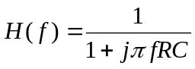  - Prove that the mean and variance of a random variable X having an uniform distribution in the interval [a,b] are:  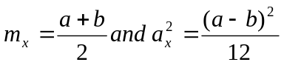 | 7  8
 | - In a (7,4) Hamming code, the generator matrix G is given by  G = 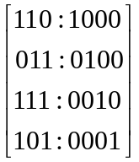A message word is coded into a code word and is being transmitted. If the receiver receives the code word (0110001), determine whether the received code word is error free or not. If the code word is not error free, determine which bit is in error.  - "In an FM receiver, to use an amplitude limiter is advantageous. In the amplitude modulation receiver, we didn't find it advantageous to use a frequency limiter". Discuss. | 9  6
 | - Discuss the SNR improvement process in FM using pre-emphasis and de-emphasis networks.  - Explain channel SNR and output SNR. Derive the expression for Figure of Merit of SSB. Elaborate the result obtained. | 7  8
 | Write short notes on any two:  - QAM  - Ergodic process  - Threshold effect in an envelope detector | 2×5

